FANUC Robot Arm Power Box

Version 1.0

Date: 12/17/20

Author: Nikolai Tiong

# Overview

The Power Box is a customized attachment for the FANUC robot arm in the Venture Lab. It provides Power over Ethernet (PoE) through the conduit that goes up the arm to any device attached to the end of the arm.

Features:

* 25 Watts total power available
* 12V, 5V and 3.3V rails with screw terminals for connecting 20-24 AWG wires
* 5V USB and 3.3V USB
* Voltage and current displayed on the 5V and 3.3V buck converter modules
* A PoE port and a non PoE network port
* Fits above the conduit that leads to the end of the arm and screws into existing holes on the arm
* Case is 3D printed using the QIDI X-MAX printer in the Innovation Den lab

The 3D model is called PowerBoxV15.f3d

Power is provided by connecting an Ethernet cable to a PoE enabled switch and the other end is connected to the port indicated by the yellow cable on the figure below. Currently, doing this will cause the 2 buck converters to immediately turn on. A hardware will be added to prevent this from happening and give control over when power is enabled.

To Do:

* Add a power switch
* The buck converters requires a button sequence to turn USB power on, find a way to bypass the controller and make it always on

# Hardware

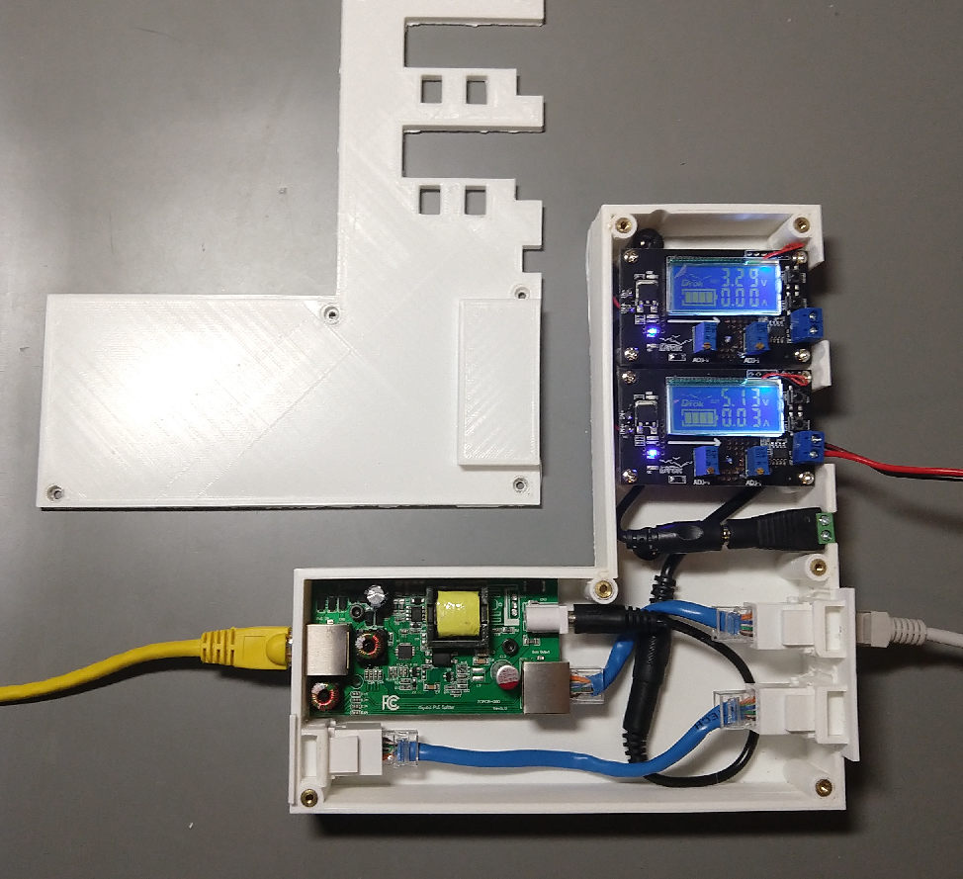

Figure 1: An open case look of the Power Box

Figure 2: Diagram of the layout of the Power Box Hardware

# Hardware Purchased:

1x 25 W PoE Splitter $29

This takes a PoE enabled port and splits it up into a 12V DC barrel jack and non PoE networking.

<https://www.amazon.com/GAT-12V25W-Volt-Splitter-Divided-Ethernet/dp/B07D7HYWQF>

2x Buck converter $14

These takes the 12V DC power from the splitter and converts it to 5V and 3.3V DC power. The modules can be voltage and current adjusted via the potentiometers, but will be covered with a silicone sealant to prevent accidental modifications.

<https://www.amazon.com/M%C3%B3dulo-convertidor-ajustable-reductor-voltaje/dp/B07JZ2GQJF/ref=sr_1_8?dchild=1&keywords=buck+converter&qid=1599240640&s=electronics&sr=1-8>

1x Cat 6 F-F Keystone jack 10 pack $11

Used inside the power box

<https://www.amazon.com/VICTEK-Female-Keystone-Couplers-White/dp/B01JJ46JX4>

1x Screw Terminal block 50 pack $8

The buck converters had the output screw terminals on the wrong side – it prevented using the screws to tighten wires when facing upright. De-soldering the terminal blocks left them unusable and were replaced with these.

<https://www.amazon.com/DGZZI-50pcs-Terminal-Connector-Arduino/dp/B07SZFGH4B/ref=psdc_306731011_t1_B07CK3RCKS>

1x 15 12W POE Voltage Splitter $17

This was the first PoE splitter bought. It didn’t provide enough power to boot up a Raspberry Pi 4.

<https://www.amazon.com/WT-GAF-12v12w-802-3af-Splitter-Ethernet-Switches/dp/B017J8WJ5E/ref=rtpb_4/180-1860657-9022248?_encoding=UTF8&pd_rd_i=B017J8WJ5E&pd_rd_r=d52ed668-65b6-46d9-a8db-63b9e7113c25&pd_rd_w=ASScB&pd_rd_wg=Uc3Ui&pf_rd_p=1060fc32-cc06-48f1-987d-6b74a57cd8f2&pf_rd_r=DJR61SPSEB77J4YV1P6E&psc=1&refRID=DJR61SPSEB77J4YV1P6E>

2x 3:1 DC Wire Splitter $7

Takes the 12V DC from the splitter and provides 3 lines.

<https://www.amazon.com/Litever-Power-Splitter-Female-Plugs/dp/B075B222S4>

1x 20 pack DC Barrel to screw terminal $5

<https://www.amazon.com/Female-Power-Adapter-Connector-Camera/dp/B01ER6QWAY/ref=rtpb_2/180-1860657-9022248?_encoding=UTF8&pd_rd_i=B01ER6QWAY&pd_rd_r=0e7585ca-6590-4865-b017-d1a0a799eeaf&pd_rd_w=YcrFI&pd_rd_wg=Siwc5&pf_rd_p=1060fc32-cc06-48f1-987d-6b74a57cd8f2&pf_rd_r=DGSTYDEZNPKCRX8C5RBT&psc=1&refRID=DGSTYDEZNPKCRX8C5RBT>

1x 5 pack DC male to male cable $12

<https://www.amazon.com/Power-Adapter-Patch-Cable-2-1mm/dp/B07PFZ1XCC/ref=psdc_172544_t1_B00I6O1QAA>

1x 50 ft 20 AWG Stranded Copper wire $9

<https://www.amazon.com/American-Stranded-Conductor-Power-Speaker/dp/B0791B4ZRW/ref=sr_1_1?dchild=1&keywords=20+awg+dc+copper+wire&qid=1599244168&s=electronics&sr=1-1>